UX report

* **Nielsen & Molich design principles**

Visibility of system status:

Users are always informed about current state and actions through appropriate visual cues. When the page takes longer to load a loading message appears. In case there is no data the user can see a message stating that. When something goes wrong, or the user gets disconnected the application redirects to the appropriate page showing the issue. Here are some examples:

Match between system and the real world:

All the buttons are labeled in plain English, and the appropriate colors are being used for certain buttons such as “delete” and pink for the rest because it is related to the platform theme. Here are some examples:

User control and freedom:

The system has “Go Back” buttons on all the needed pages/features or “Cancel” one.

Error prevention:

The application has warning messages that appear when something is not right such as missing data warnings that give some insight on the error, message when a provided data has incorrect format or when deleting an account there is a confirmation message:

Help users recognize, diagnose, and recover from errors:

All messages clearly display the warning in plain English. It can be seen in the previous images.

Consistency and standards:

Buttons follow color standards: “Delete” is red, all the rest buttons are pink because it is the theme color of the platform.

The Search bar feature and the sorting buttons use the default naming:

Recognition rather than recall:

There are buttons that show hidden information: when a Parent checks the “Job Application” they can also check the Babysitter. For the Babysitter - check Poster:

Flexibility and efficiency of use:

When creating a Poster, the user can use a calendar instead of manually typing the date which saves time and data mismatch. Another simplified feature is the account creation - the user role is selected from a combo box:

Aesthetic and minimalist design:

The links in the navbar contain max 2 words avoiding unnecessary information:

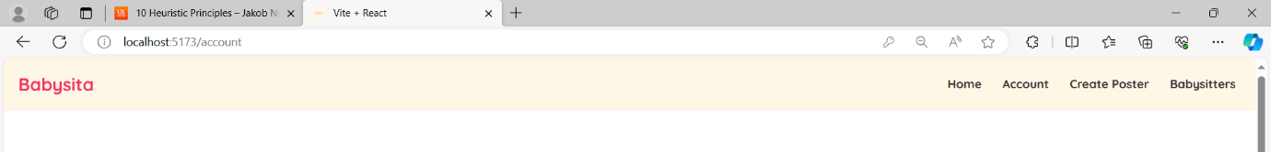

Help and Documentation:

The platform is very easy to use and because of that does not provide manuals for that. The system itself does not support bot helper because it is out of the scope for Semester 3.

Changes after the 10 principles:

I haven’t change anything based on the principles because I already follow them. It was a good experience to rad them so for feature projects I can prevent design mismatches and UX confusion and inefficiency.

* **Feedback on the UX design of “Babysita”**

**The following feedback was gathered on 01/12/2023 during Cultural Awareness class activity (Sprint 4):**

**Radislav:**

Neat design, fits the theme of the website perfectly, functionality is present and outstanding in my opinion. Design wise profile pipctures could use some rounding also searchbars can be stylized a bit(some nice border and bg color).

**Andrei:**

Great job on implementing all the features, you are clearly ahead of schedule and are mostly done with your project. Your design, although not very complex, is still very nice to look at, and looks very polished. You don't seem to have issues with your code, so that's good. Only thing I could ask for is maybe make the text a bit bigger, and make the "My posters" and "My job applications" a bit more visible.

**Daan:**

It's nice you have a tutorial a the home page, you have a lot functionality already as well. I would make the textboxes bigger so they are more readable

**Urtė:**

I really liked your application, it has a lot of functionalities and I actually enjoyed the design :) Your application seems easy to use and I think you should leave the home page with the explanation how to use it. Seems like you took a lot of time doing the front end, good job!

**Ivan:**

a lot of fuctionality implemented, the design looks nice, i like the the main idea of the project. i suggest you to make the profile page bigger because you have a lot of white space or maybe you can add something else in those pages

**Vedant:**

The application is great with tons of working functionality. Also the color choice is very good in terms of its topic. The only thing he can improve is the form size with the edit buttons. Also in some cases the decline button should be red color. Rest I think everything is up to mark.